- Squat

The squat is an exercise to train your Hamstrings and hips.

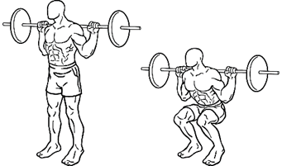

1. Stand up straight.
2. Keep your arms at the level of your shoulders.
3. Lower your legs slowly.
4. Make sure your knees are at a 90-degree angle.
5. Go back up slowly.

Repeat this exercise 10 more times, good luck.

- Push up

Push-ups is an exercise to train your arms.

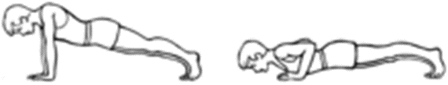

1. Lie down on the floor.
2. Make sure your hands are on the floor and your toes.
3. Lower down slowly and touch the floor with your chest.
4. Go back up.

Repeat this exercise 5 more times, good luck.

- Dip

With the Dip, you try to raise yourself on the Dip bar with your arms so you can train your arm muscles.

1. Grab the parallel “Dip bars”, jump up and straighten your arms.
2. Bend and cross your legs so that they are stable and to lower yourself deeply.
3. Lean forward slightly, but make sure to keep your body straight. Lower your body by bending your arms.
4. Zip down slowly and steadily, make sure that you keep your elbow at shoulder level.
5. Lift your body back up at a rapid pace by extending your arms fully. Then exhale.
6. Brace your elbows for a moment.
7. Repeat from step 2.

Do this exercise 5 more times. If you think its easy do it 10 more time, good luck.

- Plank

Planking is an exercise to get a stable hip. Lay down and use your arms to try to stay as steady and straight as possible.

Lie down on the floor.

1. Keep your elbows at a 90-degree angle below your shoulders.
2. Support your body with your elbows and your toes, and make sure your back is straight.
3. Try to stay straight as much as possible.
4. Hold this position for 30 seconds.

Good luck with the exercise.

- Donkey Kicks

The Donkey kick is an exercise to train your hamstrings. If you do the exercise you can feel it in your hamstrings, if you don't feel it there you are doing it wrong.

1. Lie with your elbows and knees on the floor with your face toward the floor.
2. Stretch your right leg back. Don't overdo this.
3. Keep your leg straight for a few seconds, then return to the original position.
4. Now repeat this exercise with your other leg.

Do this 10 more times. Good luck with the exercise.

- Mountain climber

The Mountain climber is an exercise. Where you are doing as if you are walking up a mountain. It trains your stamina and balance.

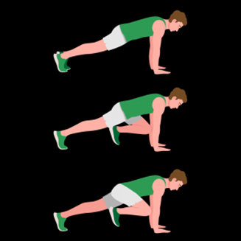

1. Lie down and put your hands on the floor and lean on your toes.
2. Tighten your abs and glutes.
3. Always bring 1 leg towards your arm.
4. Repeat this exercise 10 times.

Good luck with the exercise.

- Burpee

The Burpee is an exercise that looks like a push-up. After doing the push-up, you jump with your hands in the air. You can train your whole body muscles with this exercise.

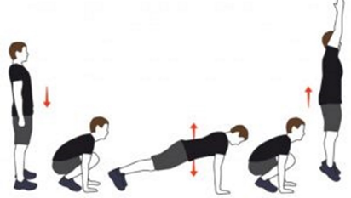

1. Lie down in a push-up position. Make sure you do this with a straight back.
2. Jump your feet toward your hands and push yourself up with your legs.
3. Keep your arms straight during the jump
4. Place your hands on the floor first on the landing and then return to your push-up position.
5. Now repeat the exercise.

Do this 2 × 10 times. Good luck.

- Lunge

The lunge is an exercise that trains your butt muscles and hamstrings.

1. Stand up straight and put both hands on your hips.
2. Take a big step forward with 1 foot, making sure that the knee is at a 90-degree angle.
3. The other knee should also be at a 90-degree angle and just barely touch the ground.
4. Stay in this position for 5 seconds and then return to the starting position.
5. Now do this with your other leg.

Repeat this 10 times. Good luck with the training.

- Wall sit

With the wall sit, you train your belly and back muscles. Your knees should be 90 degrees and your back should be against the wall.

1. Find a wall and stand with your back against it.
2. Push your back against the wall and slowly lower yourself down into the squat position.
3. Keep tension in your thighs, abs and make sure to keep your back straight.
4. Hold this position until the time is up.

Do this exercise for 35 seconds. Good luck.

- Crunch

A crunch is an alternative to a sit-up. Because with the Crunch, you train your straight belly muscles. This is a very good exercise to train your belly with

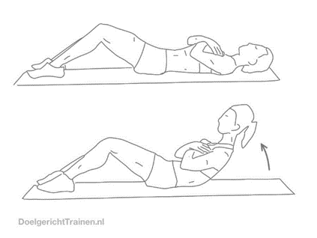

1. Lie on your stomach and make sure your knees are at a 90-degree angle.
2. Put your hands on your chest.
3. In that position, slowly lift your shoulders towards your knees.
4. Now lower back, but do not touch the floor, repeat this exercise 10 times.

Do this 20 times if you finished it easy.